LAB - 3

Demonstration of Unix Commands: cmp, comm, diff, chmod, chown, chgrp, ƒile, ƒinger, sleep, kill, ps, wc

Part: A

1. Perform the following Unix Commands: cmp, comm, diff, chmod, chown, chgrp, ƒile, ƒinger, sleep, kill, ps, wc
( || = or and && = and )
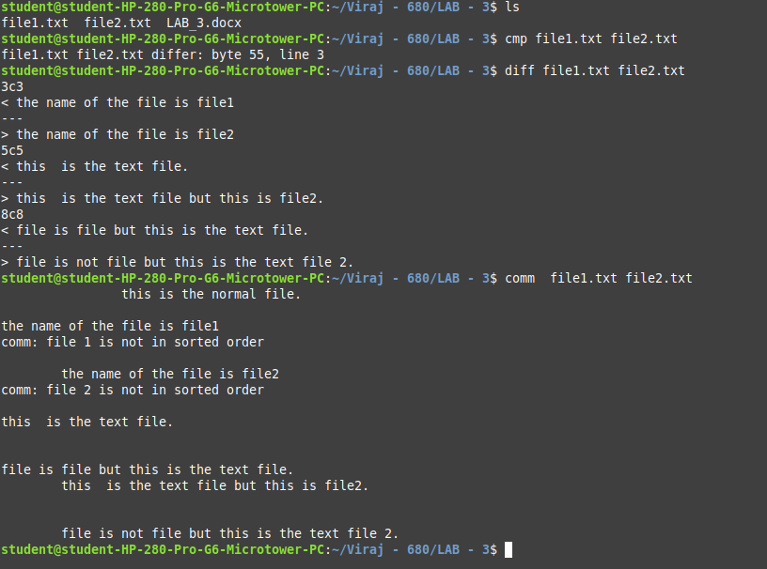

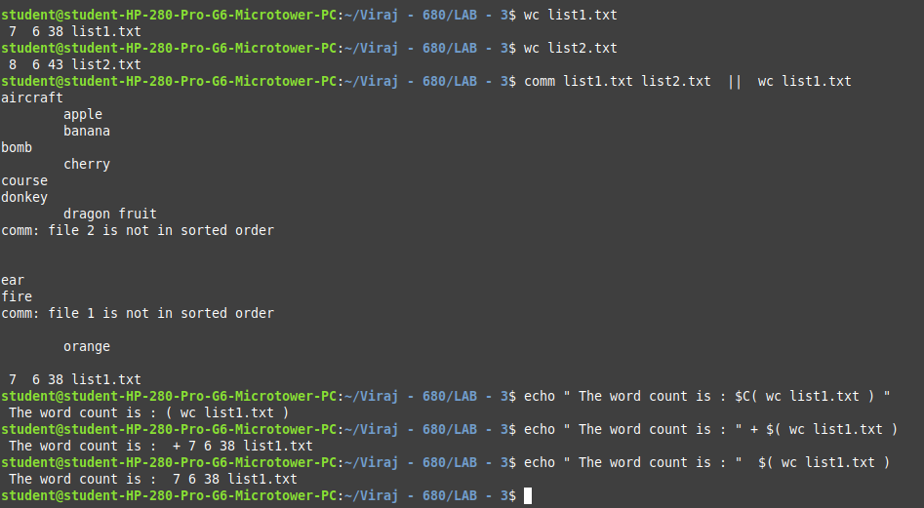

Part: B

1. Compare two files file1.txt and file2.txt, and if they are different, display a message and count the number of lines in file1.txt.

2. Compare the contents of config_old.txt and config_new.txt, and if there is a difference, change the permissions of config_new.txt to read-only for all users.
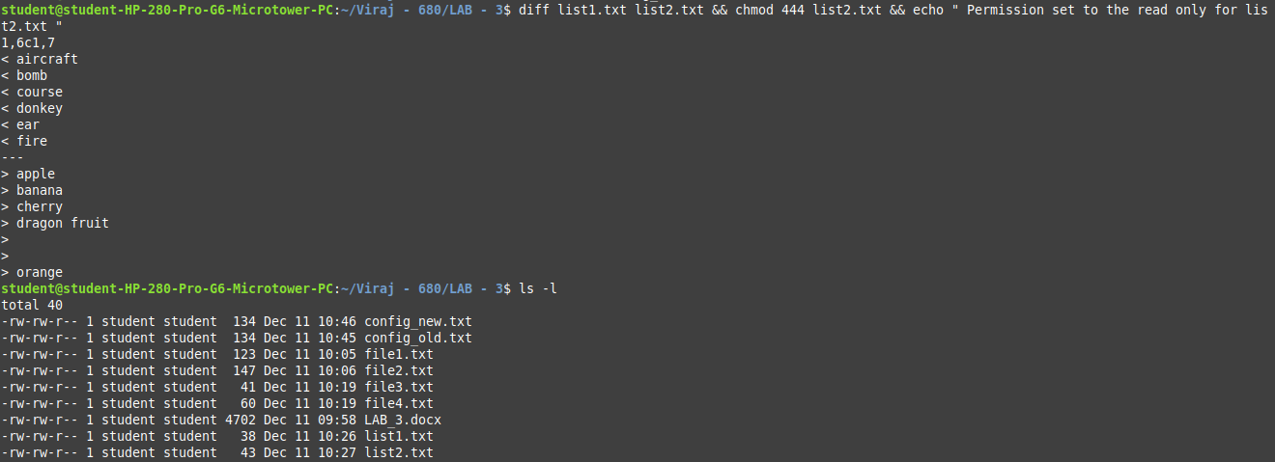

3. Check the type of file1.txt, compare it with file2.txt, and if they differ, count the number of words in file2.txt.

Part: C

1. Compare two sorted files list1.txt and list2.txt using comm, check the type of list1.txt, and count the number of lines in list2.txt.

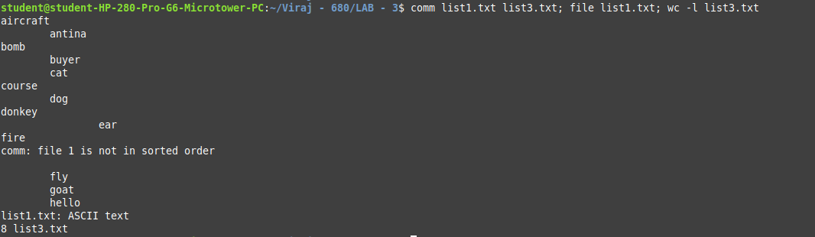

2. Compare two files data_old.csv and data_new.csv, and if they differ, count the number of characters in data_new.csv and display the result.
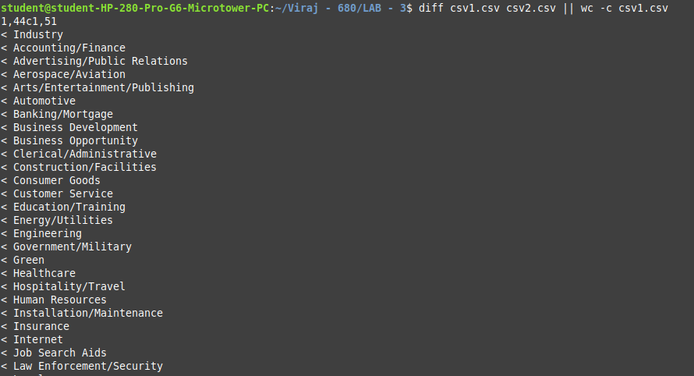

3. Change the permissions of a file script.sh to be executable by the owner, change the ownership to user diet, and after 5 seconds, print a confirmation message.

